**Business Requirement Document - Pooch**

**Dog application priority features**

1. List nearby dogs for adoption
2. Review animal shelters
3. List nearby dog grooming services
4. List nearby dog kennels / dog boarding services
5. Schedule vet services
6. Schedule dog walks
7. Dog meetup
8. List popular dog products for sale on sites like PetSmart, Petco.
9. Hold medical records of dogs.

**Preface:**

IBIS estimates that the dog-walking market is worth approximately 900 million. This market is growing rapidly every year. Dogs are man's best friend. It has been reported that there are 90 million dogs in the United States and 44% of all households have a dog. Dogs need attention 24/7 and this doesn’t allow the dog owners to leave the dogs at home while traveling for work or vacation. A lot of people are holding back their desire to own dogs because of that reason. This is a huge market which is growing rapidly every year with an increase of 4% every year. There are not many web applications in the market that deal with this market and we believe that our product will be successful in this market based on the research we did. There are many web applications in the market that only deal with specific tasks of taking care of dogs. For example, Wag is an application that mainly deals with dog walking. It is similar to Uber for dogs. There is another application called Rover which deals with dog walking, dog boarding, house sitting, drop-in visits, and doggy daycare.

There is no application in the market that deals with multiple aspects of taking care of dogs. We are planning on developing an application that will help the dog owners to take complete care of their dogs. We will let the dog owners to manage multiple dogs that they own from their user account. We let the users create profiles for their dogs in which they care to store all the details including the medical records of the dogs. We provide features such as adopt a dog, scheduling vet appointments, finding nearby dog walkers, dog meetups, dog boarding, and finding nearby dog services and stores. Our application is an “all in one application” for the dog owners. The success of our application will be based on the user reviews that we get and the number of users of our application.

**Summary of the problem and your total solution:**

People are now looking into applications like Rover which provides services for dogs like dog walking, daycare, dog boarding, etc. Applications similar to rover are the solutions for people who want to own or who already own a dog during their busy schedule. Rover application provides services such as dog walking, daycare, dog boarding, home sitting, and drop-in visits. There are other pet health care applications like Vitusvet which helps manage the pet’s health. However, there is no application that provides all the facilities that help you take care of your pet.

Our solution for the problem is to create an application that contains features such as dog walking, dog boarding, dog meetup, veterinary hospitals nearby, dogs available for adoption, and dog product businesses nearby. Our application will include all these features that make it unique from all the available web applications in the market and it would be a one-stop place for the dog owners to maintain their dogs.

**Strategy:**

|  |  |  |  |  |
| --- | --- | --- | --- | --- |
| Problem  1.Difficult to take their dogs everywhere they go.  2. It consumes a lot of time to look for dog products and vets on the internet.  3. Do not have enough time to take care of their dogs. | Solution  1. Dog walking feature like uber.  2. Show nearby dog product stores and veterinary hospitals.  3. Dog wash at home and dog visits. | Value proposition  Our solution is worth buying because it would be a goto application for dog owners which will help them to completely take care of their dog needs. | Unfair advantage  1.Customer care  2. User reviews by actual customers who used the products. | Customers segments  1.Customers who already have dogs.  2. Motivating people who to have a dog but are unable to buy it due to a busy schedule.  3. Looking to adopt dogs.  4. Dog shelters.  5. People who have lack of time to walk their dogs.  6. Pet stores.  7. Veterinary clinics  8. Dog walkers.  9. Dog kennels and dog boarders. |
| Key metrics  1. Number of customers using the application.  2. Number of people using this application to work on dogs.  3. Income from all the business transactions. | Channels  1.Internet advertisements  2.Advertisements in the places where you buy dogs.  3. Advertisements in veterinary clinics.  4. Advertisements in pet food stores. |
| Cost structure  There is no cost to run this business initially but as the business grows, there would be salaried employees taking care of customer service and servicing of the application. | | | Revenue stream  This business would be completely commission-based. The more people use the application, the greater would be the income from commissions. There would be revenue from advertisements as well. | |

**SWOT:**

|  |  |
| --- | --- |
| Strengths   1. Features that will be provided. 2. Customer service. 3. User feedback and reviews. | Weakness   1. Easily imitable business model. 2. It is a commission-based income. |
| Opportunities   1. Increase in the number of people who own dogs. | Threats   1. It takes time to earn people’s trust in the application. 2. Rover is a huge application that has taken over the pet services. It is currently a monopoly and our application has to compete with it. |

**Competitors:**

Rover: Pros: features: dog boarding, house sitting, drop-in visits, doggy daycare, dog walking

-reviews of dog walkers

- can be booked in advance

-can set your own rates

-designed to promote repeat business.

Cons: limited to dog services.

-25% commission rate

Wag: pros: -uber for dogs.

-dog sitting

-dog boarding

-can add tips

Cons: - sets the rate for you

-40% commission rate

-harder to get repeat business

Petbacker: features: dog walking, pet sitters

Pros: comprehensive rating and review system where you can talk about the cost

for service.

Cons- 25% commission rate

**Segment Profile:**

|  |  |  |  |
| --- | --- | --- | --- |
| Geographic  All over the United States | Demographics  Dog owners | Behavioral  Interest in and enthusiasm for dogs | Buyer power  This app can be used by every dog owner who has the capacity to take care of his/her dog. All segments of people can afford services on this application. |
| Size  It is a huge segment with 60 million dogs. | | Growth potential  This market is growing at a rate of 4% every year. It is going to increase more as the buying power of the Millenials increases in the coming years. | |
| Competitive activity   1. Rover 2. Wag 3. Petbacker 4. Other small companies | | Risk  This market is increasing at a rapid rate.  The first risk is that the business will have a downfall only if the growth rate of people having dogs go down. The second risk is the inability to gain traction with the target demographic. | |
| Approach  Our application will have a lot of features that will benefit the users making their job of taking care of their dogs easier. There will be a mobile application to make this application more available to the user. | | | |

**Primary Market Research:**

Questions:

How likely are you to download a dog care app if it contained each of the following features?

1. Adopt a dog?

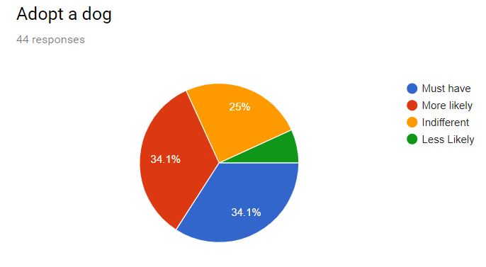

1. Schedule vet appointments?

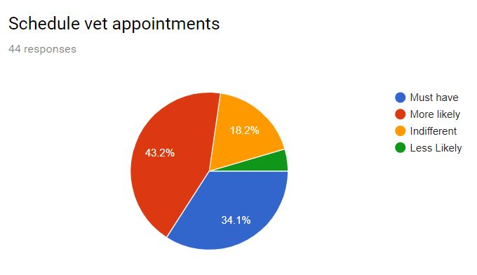

1. Find a dog walker?

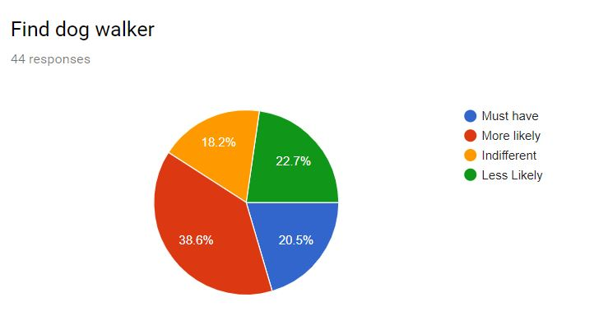

1. Schedule dog meetups?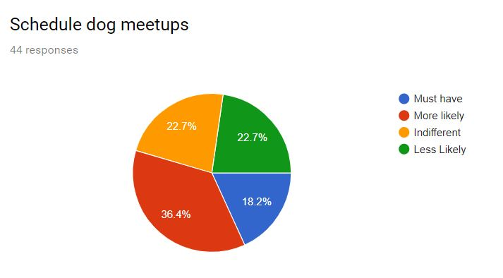
2. Find nearby dog services?

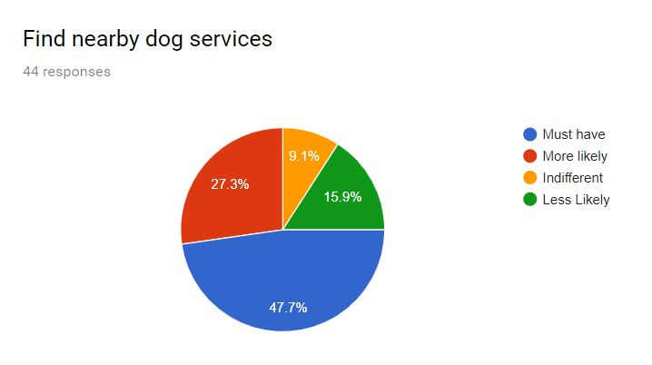

1. Dog boarding?

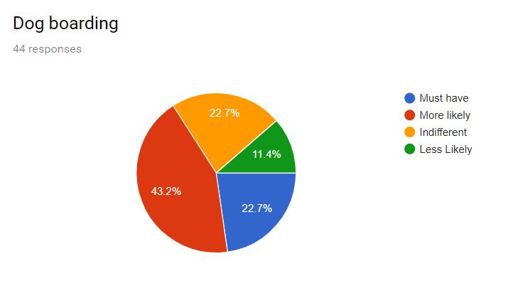

1. Are you using any pet application to take care of your dog?
2. What do you think about our dog application?
3. What features of our application impresses you the most?
4. What features of our application do you think is a waste?
5. What features do you wish that a dog application should have as compared to the others which are already in the market?
6. On a scale of 5, how much do you rate our application?

**Secondary Market Research:**

* Dogs are man's best friends. A lot of people own dogs in the United States.
* The dog service market is huge and is growing hotter and hotter every day.
* There are now more pet holding houses as compared to families that have kids. The number of families having kids is just 53 million as compared to families that have pets which is 85 million according to Statista.
* Today nearly 70% of all U.S. households own a pet, with dogs by far the most popular pet, according to the [American Pet Products Association](https://www.americanpetproducts.org/press_industrytrends.asp).
* About 60.2 million households’ own dogs, compared to 47.1 million that own cats.
* There has been an increase in this industry because of the Millennials.
* Millennials are on their way up in terms of income and spending and their overwhelming passion for their pets will drive the dog businesses in the future.
* Zulily conducted research and mentioned that: Our customers are purchasing pet products year-round and love to involve their pets in every aspect of their lives, from birthdays to walks in the park to even thematic kitchen and home décor – since they are seen as an extension and beloved member of the family,” explains Kerry Gibson Morris, Zulily VP of merchandising, noting that the company currently offers some 250 brands for pets.
* The market is very big, and the pet owners are willing to spend a lot of amount taking care of their pets.
* In 2017 there were approximately 89.7 million dogs owned in the United States, according to a pet owner survey made by **Statista**.

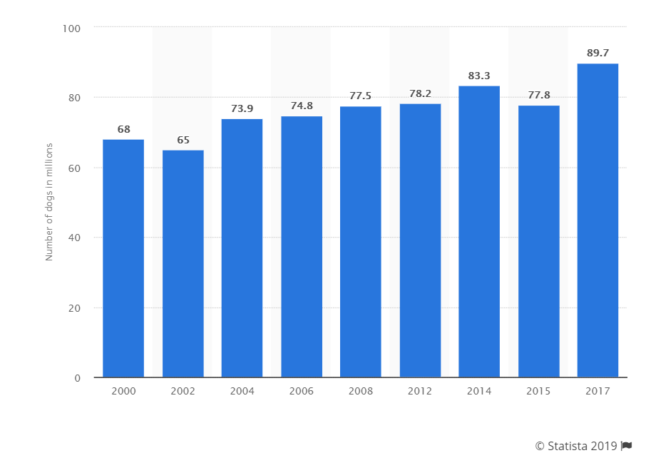

* Each year, approximately 1.5 million shelter animals are euthanized (670,000 dogs and 860,000 cats). The number of dogs and cats euthanized in U.S. shelters annually has declined from approximately **2.6 million** in 2011. This **decline** can be partially explained by an increase in the percentage of animals adopted and an increase in the number of stray animals successfully returned to their owners.
* About 710,000 animals who enter shelters as strays are returned to their owners. Of those, **620,000 are dogs** and only **90,000 are cats.** This means not many people are giving out their dogs for adoption. There are a lot of dogs in the US.
* Dogs need 100% more vet visits than cats.
* **Resources:**
* <https://medium.com/radicle/is-the-dog-walking-market-17x-larger-than-consensus-e5efc37b36e0>
* <https://www.forbes.com/sites/pamdanziger/2018/10/18/the-pet-retail-market-is-hot-and-getting-hotter-by-the-day/#47202ad7ecdd>
* [**https://www.ibisworld.com/industry-trends/specialized-market-research-reports/consumer-goods-services/pet-care/dog-walking-services.html**](https://www.ibisworld.com/industry-trends/specialized-market-research-reports/consumer-goods-services/pet-care/dog-walking-services.html)
* <https://medium.com/radicle/is-the-dog-walking-market-17x-larger-than-consensus-e5efc37b36e0>
* <https://www.forbes.com/sites/pamdanziger/2018/10/18/the-pet-retail-market-is-hot-and-getting-hotter-by-the-day/#47202ad7ecdd>
* <https://ridesharecentral.com/rover-vs-wag-sitters>
* <https://www.washingtonpost.com/science/2019/01/31/how-many-americans-have-pets-an-investigation-into-fuzzy-statistics/?noredirect=on>
* <https://www.statista.com/statistics/198100/dogs-in-the-united-states-since-2000/>
* <https://www.avma.org/News/JAVMANews/Pages/130201a.aspx>

**Commercialization Strategy:**

The primary target would be the dog owners/ lovers to sell our product. Marketing is very important for the commercialization of our product. Marketing on social media websites is one of the ways to market our application. Advertising in pet stores, veterinary hospitals, breeding centers, and pet food stores will help our application to gain popularity and lead to more business through the application.

**Monetization Strategy:**

Our application is service-based the main source of income would be from commissions. We are planning on having a 15% commission for every transaction happening between the customers through the app. Having a 15% commission means more number of users considering the most frequently visited apps have at least 25% commission rates. Better prices for the users would be an asset to our developers. There would be income from advertisements as well.  
**Appendix:**

**Personas:**

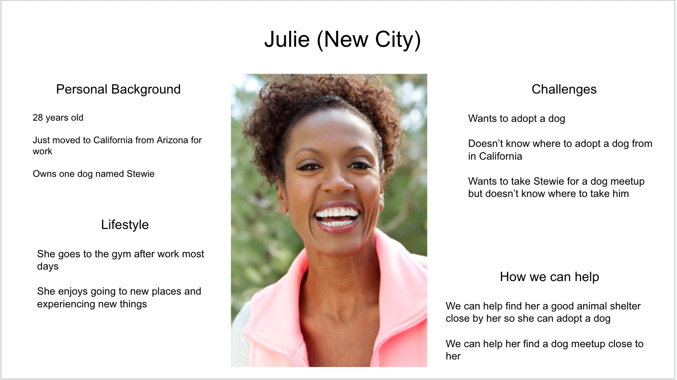

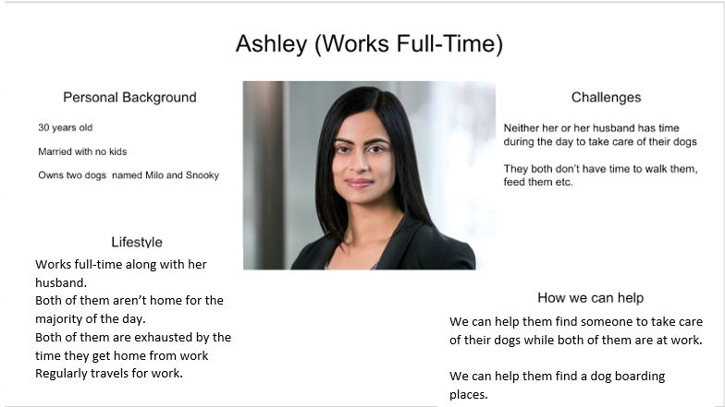

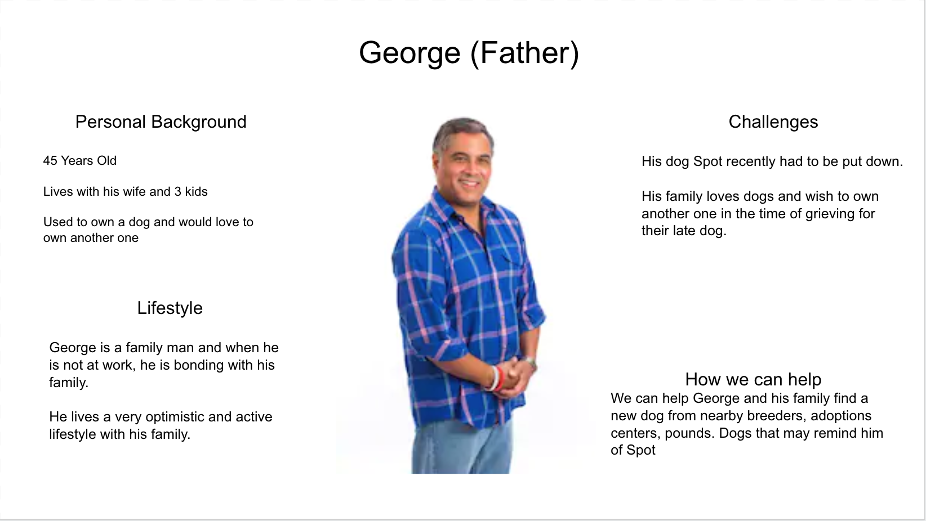

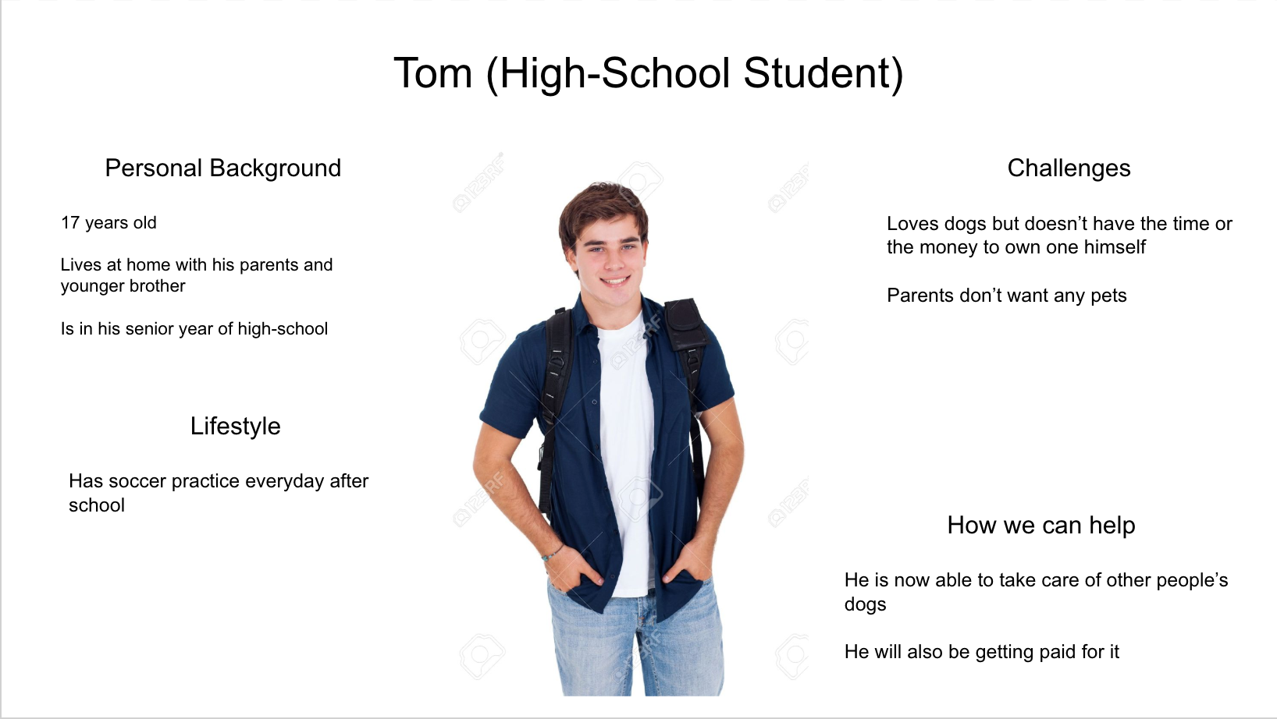

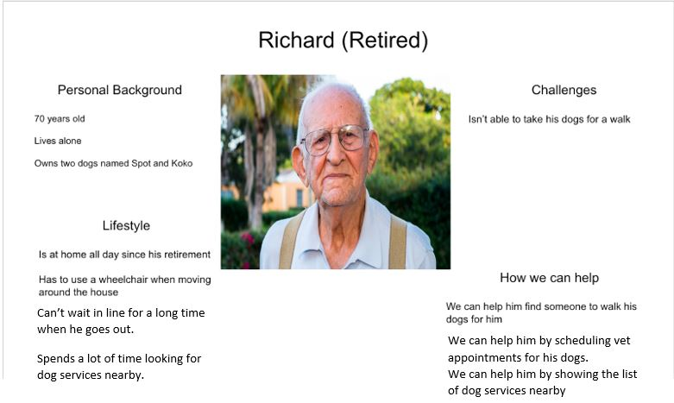

**Technical Depth:**

There are several ways to increase the technical complexity of the project. One of the ways is to create a self-generated server or incorporate testing with aspect to an appropriate rationale. However, our team decided to implement a tougher model of Machine Learning which would account as a more technological complex.

Deciding on how to know the dog breed, can depend on how much you really want to know. If you are just wondering what’s your pooch’s breed, you might be able to figure it out based on their appearance. However, if you want to know if your dog is predisposed to any health issues based on their breed, you will need to go to an expert. For instance, if you realize your pooch’s part of the Doberman Pinscher, you will know that they are predisposed to heart disease and certain neck and spine issues. So, let’s rewind for a little bit, first you will identify the certain breed of your pooch. Then, you can have different analysis based on the poochie breed and all hazards signs and symptoms can show at the point. Training the model is not as easy as it sounds, especially for dog breeds.

There are so many sub-breeds that we don’t know about. For example: if we have a “purebred dog pedigree” is not the same as “purebred dog”, due to many facts. The purebred dog pedigree owners are well aware of their prized poochies, but sometimes records are lost or forgotten. If your dog is purebred pedigree but that’s all you know, you may still be able to find out more info easily because it purebred dog. Then if that’s not the case, the model will struggle more to retrieve what’s the dog’s breed and if the breed is mixed up it will take longer to actually find what are all the signs and symptoms that the certain breed is exposed to.

Our initial business plan included the machine learning implementation of making a CNN trained (supervised) model to find whether the uploaded profile picture in the dog section is a dog or not?

But later, the developers decided that we could try and use the input from the above implemented model to find out the breed of the dogs too. This would mean more complex CNN model, which includes more training data, more time and to achieve a higher accuracy more variety of data to be fed to the learning set.

The first difficulty is that there are over 340 dog breeds (as recently recorded by Prudent Pet - Pet Insurance company as of 2019. [https://www.prudentpet.com/blog/  
newest-purebred-cross-breeds/](https://www.prudentpet.com/blog/newest-purebred-cross-breeds/)). Considering these many varieties of breeds, try and imagine the various combinations possible between the breeding species and an even bigger number of varying ratios amongst those varying combinations. This just means more data needed to accurately train the CNN training model to achieve a minimum qualifying accuracy.

Another difficulty is non availability of an open database of dog pictures with adequate labels to feed into the model, and the difficulty in finding that database to train our model.

We looked at the image classification model, but that model is a lesser accurate prediction and it needs way more datasets to train itself, because it uses several parameters to be able to identify an image, however with CNN’s reusage of the parameters, it requires lesser data for the training as compared to the Image Classification model but still a lot more data considering the total number of dog breeds and the difficulty of multi breed dogs.

An alternative way of an even simpler Machine Learning implementation would be to use the Google Cloud Vision API, to find stores and locations on the basis of geography of “near me” features. This could be implemented in a lot of the feature pages on our website by just implementing it once and reusing the same code with a slightly different input and output values to achieve the desired results.

Back to the ways to increase the complexity, one of the other ways is to implement more features. But the only concern for the developers with that idea is that users would lose interest in our website, if it offers a lot of features. We do not plan to overwhelm the users with the very large number of features besides the already existing and/ or planned ones. However, if we decide to implement the identifying the breed, then we could just as easily with a few more alterations append our application to have a feature similar to Shazam but for dogs. This would allow you to upload a picture and the model returns a string of output of the breed of the dog.

The only downside to this feature / or the idea is the complexity of the model and the unavailability of an open database.